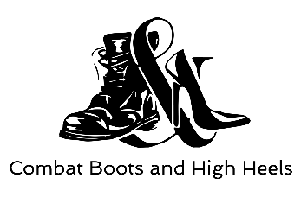
The Central Missouri Chapter of Safari Club International
Combat Boots & High Heels
in association with

SERVICE MEMBER/VETERAN APPRECIATION TRIP

Combat Boots and High Heels (CBHH) and the Central Missouri Chapter of Safari Club International (CMCSCI) would like to present the opportunity for a deserving Missouri Service Member or Veteran to go on an expenses-paid hog hunting trip at the Rockytop Ranch in Oklahoma!

DETAILS!

On February 15 – 17, 2019, three Service Members/Veterans will be provided a hog hunting adventure in the Great State of Oklahoma at the Rockytop Ranch. This is a fenced game ranch but don’t let that fool you, the hogs are wild and act like it!

You will be met by a CMCSCI member at a predetermined time/location who has hunted at Rockytop Ranch in the past and is a military veteran.

The trip package includes
- $50 in reimbursement for gasoline
- 1 management hog, you can upgrade to a trophy hog at your own expense
- Lodging/meals
- Use of cleaning shed (or awardee can pay for hog to be professionally cleaned)
- Oklahoma feral pig license

Not Included:
- Please bring your own coolers
- Alcoholic Beverages (can’t be consumed during the hunt)
- Rifle and ammunition

CONDITIONS!

Proof of military service will be required for all contest finalists. Awardee must be legally allowed to own/operate a firearm in the United States.

The Central Missouri Chapter of Safari Club International
Combat Boots & High Heels
in association with

SERVICE MEMBER/VETERAN APPLICATION FORM

Name | Telephone | Email Address
Address | City | State/ZIP
Branch of Service | Time in Service
Significant Military Accomplishments: Click here to enter text.

Why do you want to go on a hog hunt in Oklahoma? Click here to enter text.

PLEASE SUBMIT ALL FORMS TO combatboots.highheels3@gmail.com BY December 15th, 2018 to be considered!

Proof of military service required for all contest finalists

