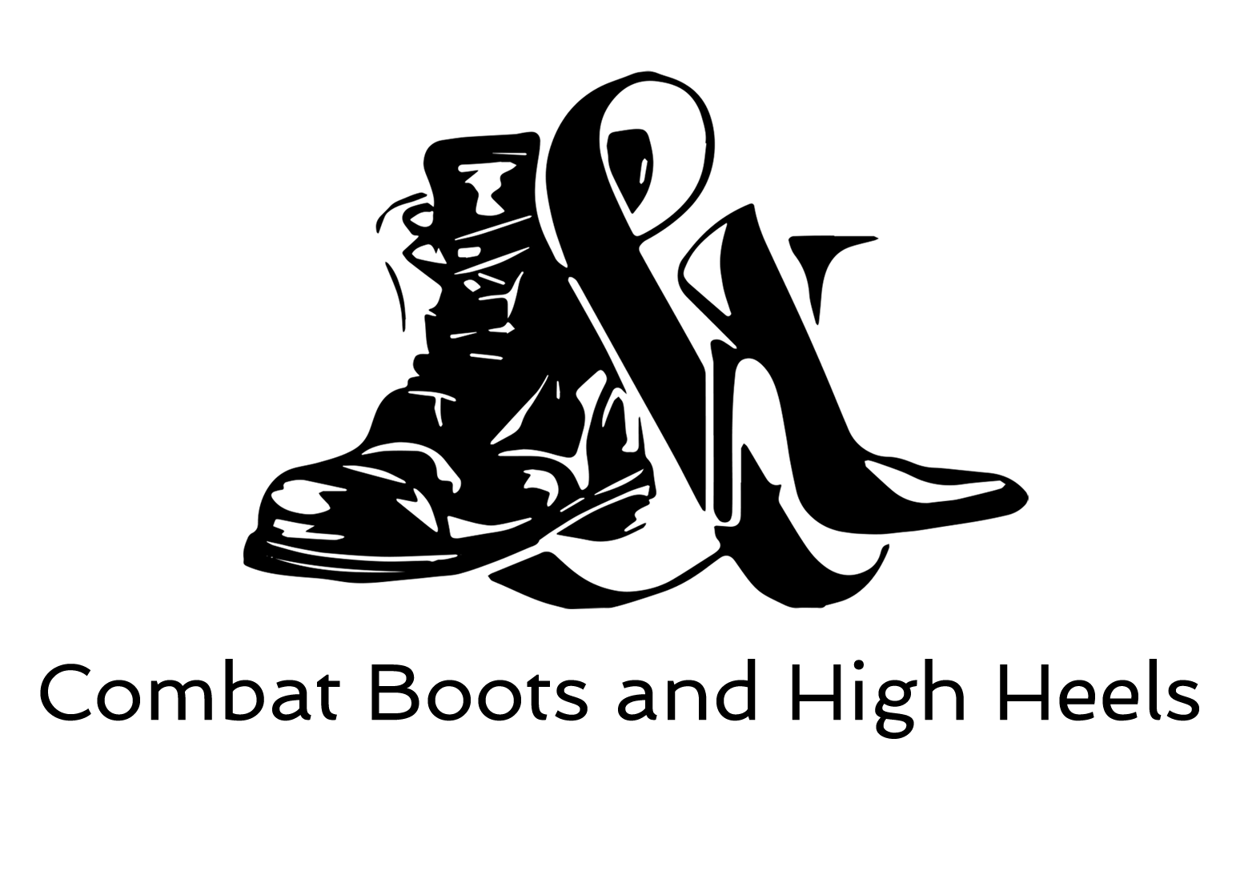

Combat Boots & High Heels
Columbia, MO 65201

CBHH Baby Essentials Box

Applicant Information
Applicant Name: | Last | First | MI

SHIPPING Address: | Street Address City State ZIP

Email Address: | Email | Phone Number: | Cell or Home ONLY

Expected Baby’s Birthday: MM/DD/YY

Baby Gender: ☐Girl ☐Boy ☐It’s a Surprise
Current Military Status: ☐Veteran ☐Service Member ☐Dependent

How did you hear about us? | Friend, Advocate, Volunteer?
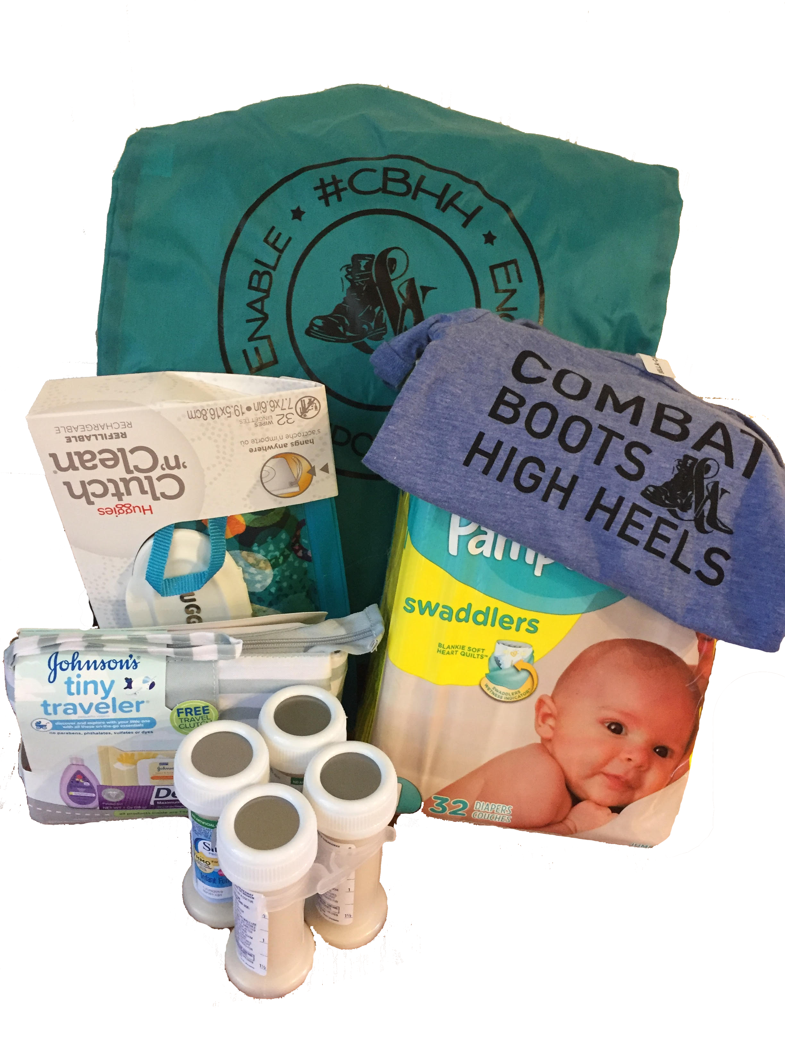
Boxes may vary, but generally include: Diapers, wipes, formula, baby traveler’s kit, CBHH onsie, and CBHH drawstring tote bag. A special thank you to Veterans United Foundation for making Operation Baby Box possible.

I certify that the information contained within this request is true and accurate to the extent of my knowledge and I have attached proof of service (examples are redacted dd-214, orders, etc)

Requestor Signature | Date

Please print this form upon completion, sign and date it, then scan/take a phone picture of it and send it to cbhhbabybox@gmail.com. You can expect a response within 72 hours of submission.

